**UI Testing for Odisha Police Website**

**1. Test Information**

* **Test Case ID**: UI-001
* **Test Case Name**: UI Testing for Odisha Police Website
* **Test Date**: 14 Oct
* **Tested By**:
* **Website URL**: <https://mtpl.work/odisha-police/>

**2. Preconditions**

* User must have internet access.
* User should be using a supported browser (e.g., Chrome, Firefox, Edge).

**3. Test Environment**

* **Browser**: e.g., Chrome
* **Browser Version**: 129.0.6668.101
* **Operating System**: e.g., Windows 10

**4. Test Steps and Findings**

|  |  |  |  |  |
| --- | --- | --- | --- | --- |
| Step No. | Action Description | Expected Result | Actual Result | Status (Pass/Fail) |
| 1 | Navigate to the website | Website loads successfully | Page should load without error | Pass |
| 2 | Check the page title | Title matches expected value | Same as expected | Pass |
| 3 | Verify the logo is displayed | Logo is visible and correctly placed | Same as expected | Pass |
| 4 | Test main navigation links (in header) | All links navigate to correct pages | Same as expected | Pass |
| 5 | Check button functionality | Buttons perform expected actions | Same as expected | Pass |
| 6 | Validate form inputs (if applicable) | Form accepts valid data | Same as expected | Pass |
| 7 | Links in left sidebar menu ( <https://mtpl.work/odisha-police/en/sun/page/our-mission>) | All links navigate to correct pages | No links are given |  |
| 8 |  |  |  |  |
|  |  |  |  |  |
|  |  |  |  |  |
|  |  |  |  |  |
|  |  |  |  |  |
|  |  |  |  |  |

**5. Visual Checks**

* **Screenshots**: (Attached screenshots failed in UI Testing)
* 

Figure outside the border

* 

Figure On hover

* 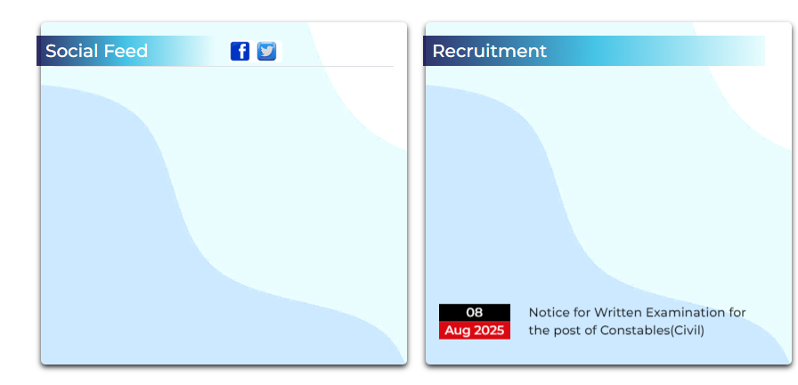

Figure blank and No social Like ( spaces could be smaller)

* 

Figure add background transparent image

* 

Figure social Link not working

* 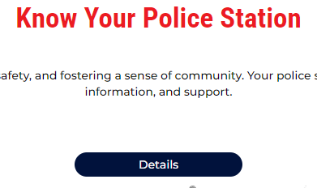

Figure details link not given

* 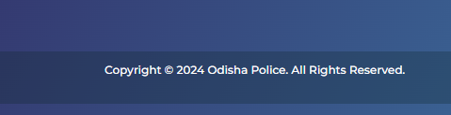

Figure vertical aligmnet should be in center

* 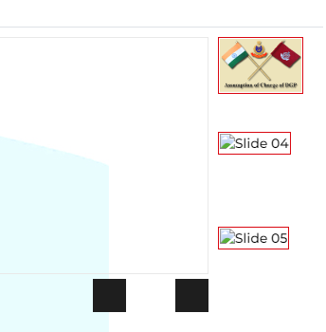

Figure dynamic image are not showing with left & right arrow

* 

Figure Helpline no not added

* 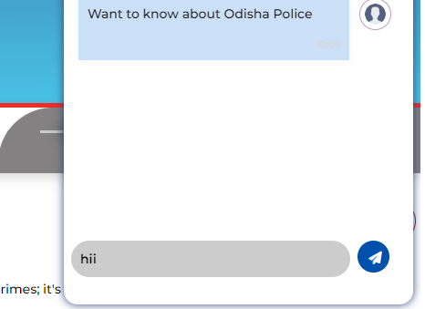

Figure chatbot button not working

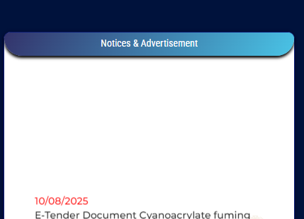

Figure clicking notice causes 404 error

**6. Accessibility Checks**

* Ensure images have alt text.
* Check for keyboard navigation and focus indicators.

**7. Performance Checks**

* **Load Time**: ON GT matrix ( failed , score: 33/100), [https://gtmetrix.com/reports/mtpl.work/id2b8W5D/#](https://gtmetrix.com/reports/mtpl.work/id2b8W5D/)
* <https://pagespeed.web.dev/analysis/https-mtpl-work-odisha-police/auj5cbl6mp?form_factor=desktop>
* **Responsiveness**: [Check if the site is responsive on various screen sizes]

**8. Defects and Issues**

| **Defect ID** | **Description** | **Status** |
| --- | --- | --- |

**9. Summary**

* **Overall Status**:
* **Comments**: